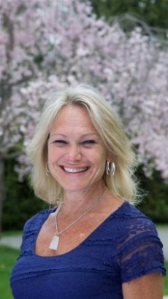
Lynn Pridmore Spirit Healing and Wellness 201-572-7771
“Using the Mind, Body and Spirit as Medicine”

Lynn Pridmore is a Certified Holistic Health Practitioner and Health Educator, with a strong focus on Energy Medicines. Lynn is also a Transformational Coach, specializing in transpersonal practices. Lynn is of the mindset that as we explore and transform internally, we begin to experience change externally.

Lynn shares her deep passion and understanding of Integrative Medicines and Natural Healing Practices by facilitating classes, lectures and workshops, and offering individual sessions which address the physical, mental, emotional, relational, environmental and spiritual needs of each client. Utilizing the Mind, Body and Spirit as Medicine, Lynn educates and empowers her clients in self-healing practices, to ensure that the benefits continue far beyond each session and class.

In addition to offering classes and sessions in her own center and online, Lynn leads weekly Integrative Wellness Lectures, as well Self-Healing with Energy Medicines classes for cancer patients at Morristown Medical Center. Lynn has also taught ongoing classes focusing on Anxiety, Depression and Stress Management at Hunterdon Hospital, wellness centers, yoga studios, various schools and KPMG.

Lynn is a certified practitioner of Jin Shin Jyutsu, Vibrational Sound Healing Therapy and Indian Head Massage. She is a Master/Instructor of Reiki and IET and certifies individuals in becoming practitioners of these modalities. Lynn is presently obtaining her certification as a Yoga Instructor.

Lynn’s clients and students range in age from 7-78. She works extensively with individuals recovering from substance abuse, and assists them in transforming addictive behaviors. Lynn teaches calming, soothing holistic practices to individuals with Special Needs (Down Syndrome, Autism, ADHD and more). Lynn volunteers several times monthly, offering complementary Energy Medicine sessions to cancer patients.

One of Lynn’s passions is to create safe, welcoming communities which provide opportunities for connection. In addition to intergenerational classes, Lynn also holds weekly and monthly classes for high school girls, young adults, women in their 20s and 30s, as well as for senior citizens. These classes are designed to provide a nurturing environment for participants to share age-specific experiences.

Lynn is a member of the Association for Comprehensive Energy Psychology, the American Holistic Nurses Association and the Natural Healing Alliance. She has presented frequently at Rutgers University and is available for speaking engagements.

Classes, sessions and further information may be found at www.SpiritHealingAndWellness.com, as well as at https://www.Meetup.com/Spirit-Healing-and-Wellness/. Please contact Lynn at Lynn@SpiritHealingAndWellness.com or 201-572-7771.

